43.52: Denote the reaction as 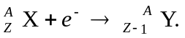
The mass defect is related to the change in the neutral atomic masses by
where 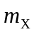 and 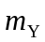 are the masses as tabulated in, for instance, Table (43.2).

